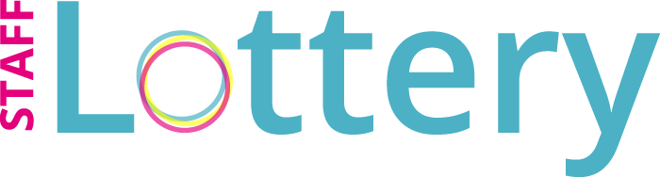 |  | Using charitable donations to improve community health services | 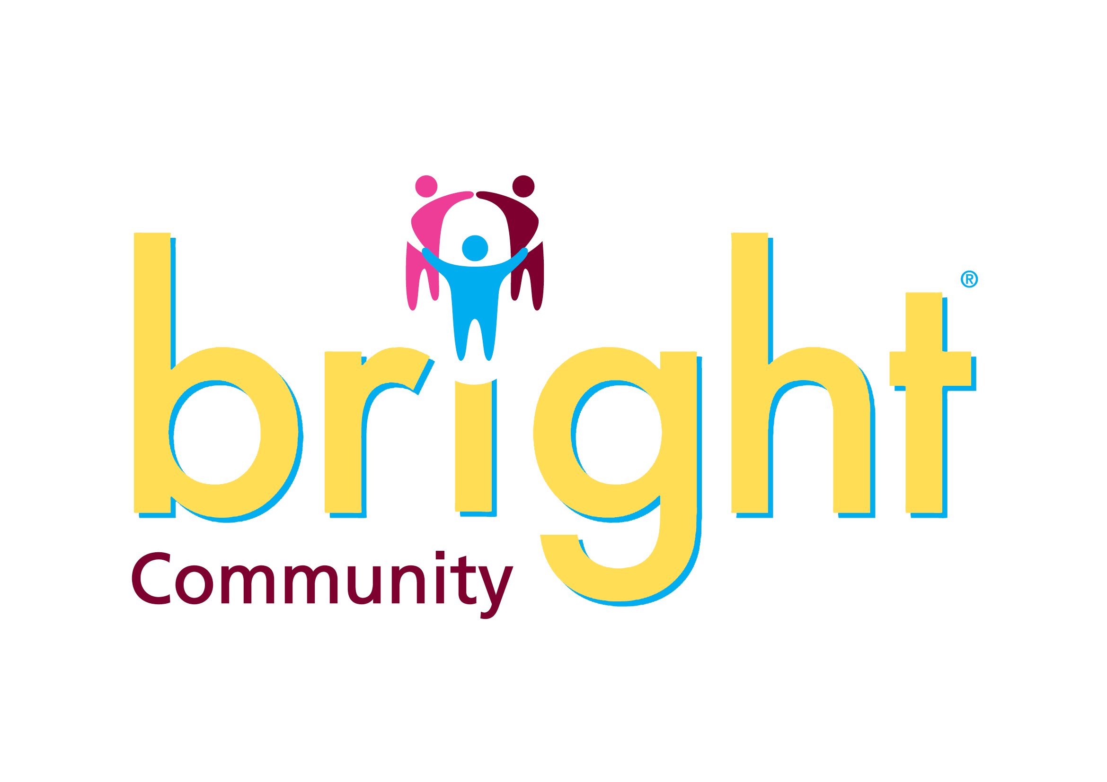
 | Staff Lottery Grant Allocation Group

Name
Department
Contact telephone number
Contact e-mail address

Description of initiative - please give full details including benefits to patients and staff. Please note the maximum bid is £1000
Please note, before submitting your bid you must contact Supplies to discuss your requirements and obtain accurate costings.

Please contact Supplies.helpdesk@northumbria.nhs.uk and include e-mail approval and quotes with your bid.

Cost of initiative excluding VAT* (max bid £1000)

* Medical equipment is not subject to VAT if purchased from charitable funds. Most other purchases will incur VAT - the Finance Dept will advise when assessing the bid.

Bid to the Staff Lottery Grant Allocation Group

Have you sought funding from other sources?
If so, please state where from – Business Unit, Department, Charitable Fund, etc.)

Approval of a Senior Manager is essential.
This can be a Business Unit Director, General Manager, Operational Services Manager, or a Clinical Director.

I hereby confirm that the bid corresponds to Trust policy and I approve its submission for consideration.

Name
Signature
Title (i.e. General Manager) |  | Date

Final Checklist
Requests for equipment have been discussed and approved with Supplies and quotes and e-mail confirmation are provided with the bid. | Yes/No
The bid has been authorised by a Senior Manager. | Yes/No

If successful, the offer of funding will be valid for 3 months only. After this period the funding will be withdrawn. Please ensure that you claim funding promptly.

Please return completed bid to:

brightcharity@northumbria.nhs.uk
Northumbria Healthcare NHS Foundation Trust
Northumbria House, 7/8 Silver Fox Way
Cobalt Business Park NE27 0QJ

Important Information

Trust policy and procurement law

All purchases made from charitable funds are subject to the trust’s normal procurement rules and processes. This means that, before any item can be purchased, it is mandatory to obtain a minimum of minimum of 2 verbal quotations.

Feedback

Successful bidders are required to provide feedback to the CDG regarding the outcome of the initiative supported with charitable funds and the benefits to patients/staff. If you do not provide this information it may affect your chances of obtaining support for future initiatives.

Advice & guidance

For advice regarding the charitable bid process, please contact:
Karen Streener
karen.streener@northumbria.nhs.uk
0191 203 1657

For advice regarding the procurement process, please contact:
June Locke
Supplies.helpdesk@northumbria.nhs.uk
0191 203 1484

For finance advice relating to charity development group bids please contact:
Lynda Bartle
lynda.bartle@nhct.nhs.uk
0191 203 1542

